Module Name: Login, Product, Cart & Checkout
Test Case ID: 183
Webpage URL: https://www.saucedemo.com/

Scenario ID: TC01
Scenario: Login with valid credentials
Test Steps:
- Open SauceDemo
- Enter username
- Enter password
- Click Login

Screenshots:-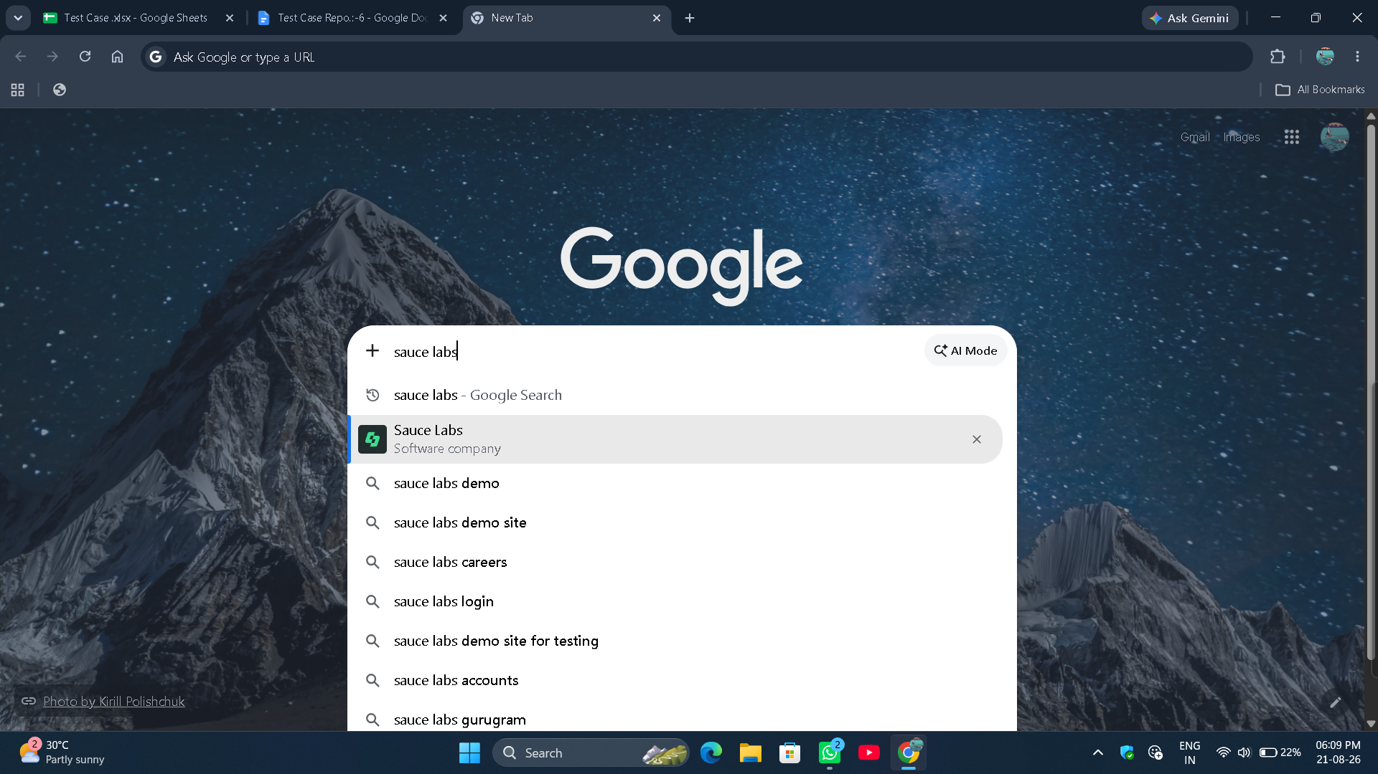

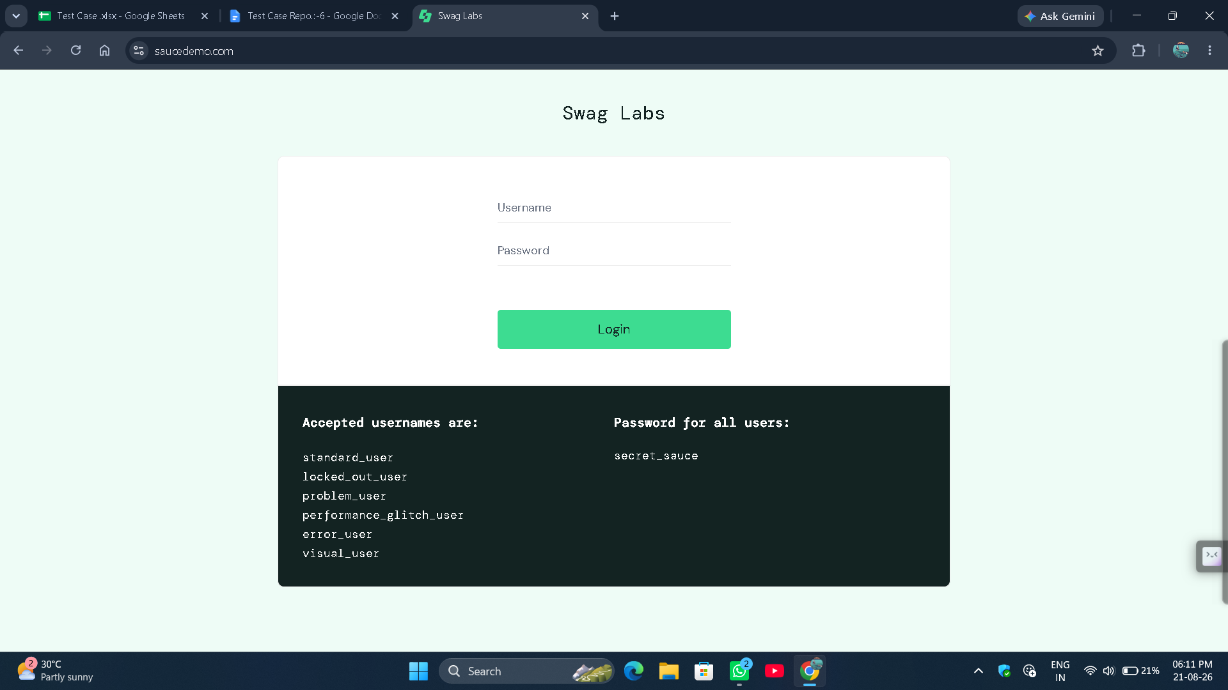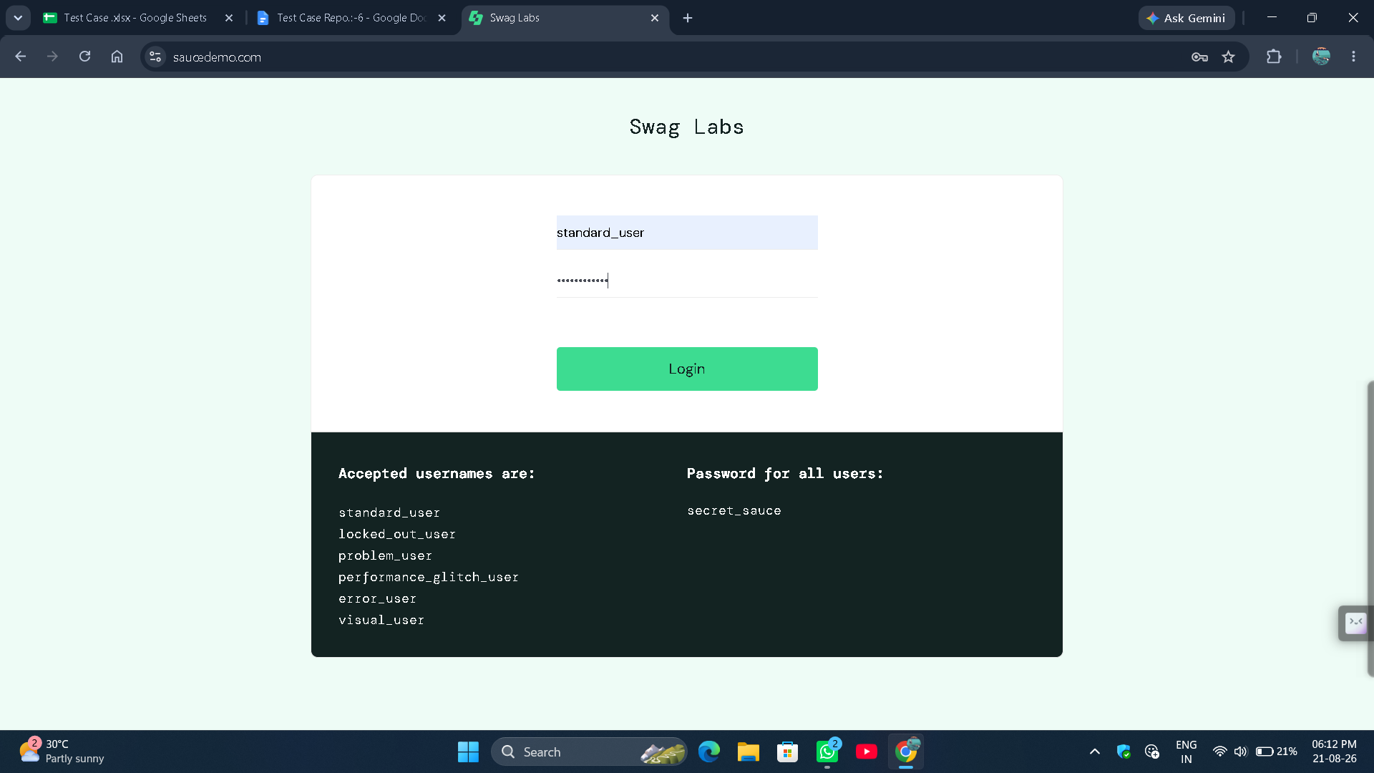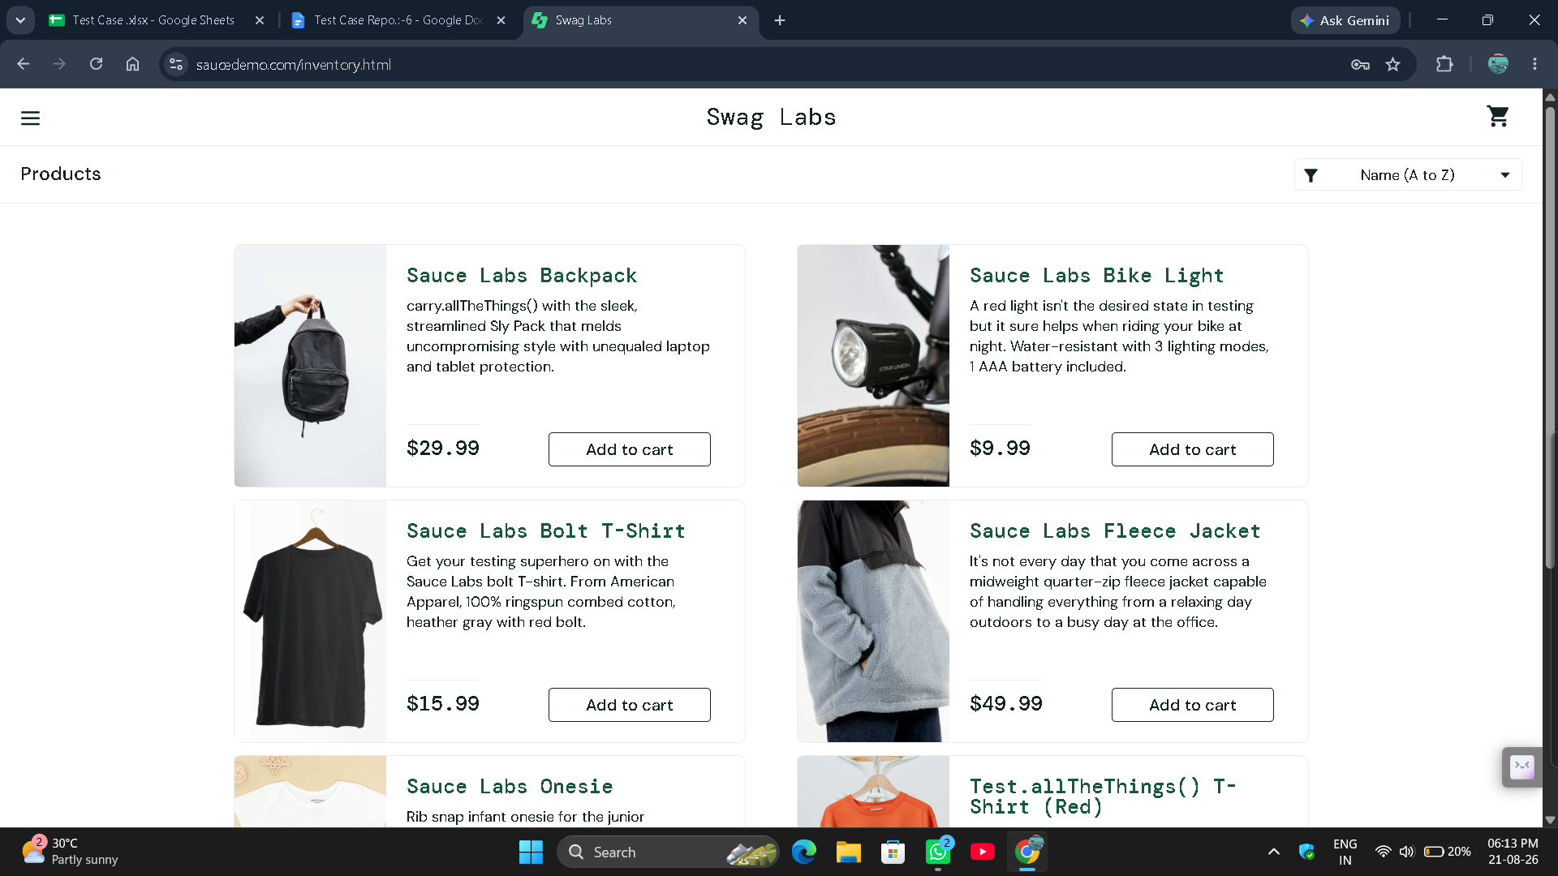

● Scenario ID: 6b
Scenario: Login with Invalid credentials
Test Steps:
- Open SauceDemo
- Enter valid Username
- Enter Invalid Password
- Click Login
Screenshots:-
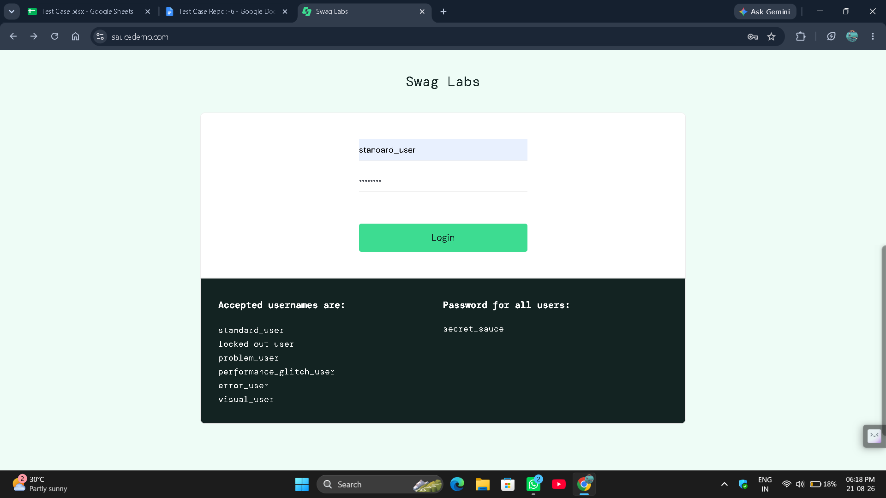
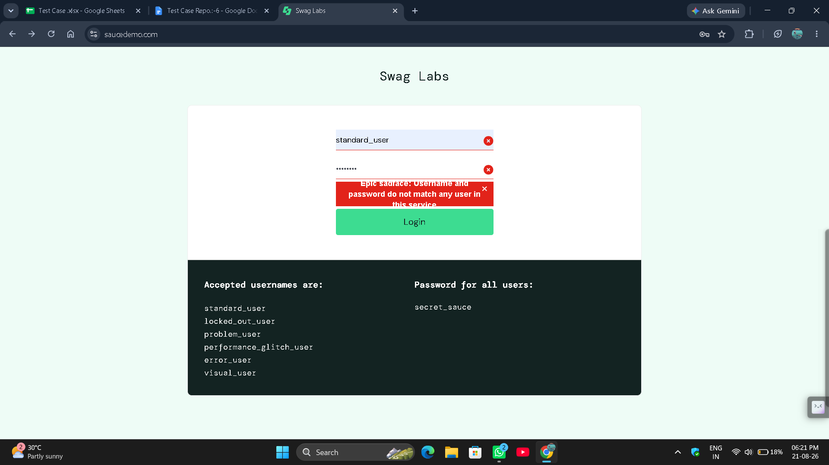

● Scenario ID: 6c
Scenario: Login with locked-out user
Test Steps:
- Open SauceDemo
- Enter username
- Enter password
- Click Login
Screenshots:-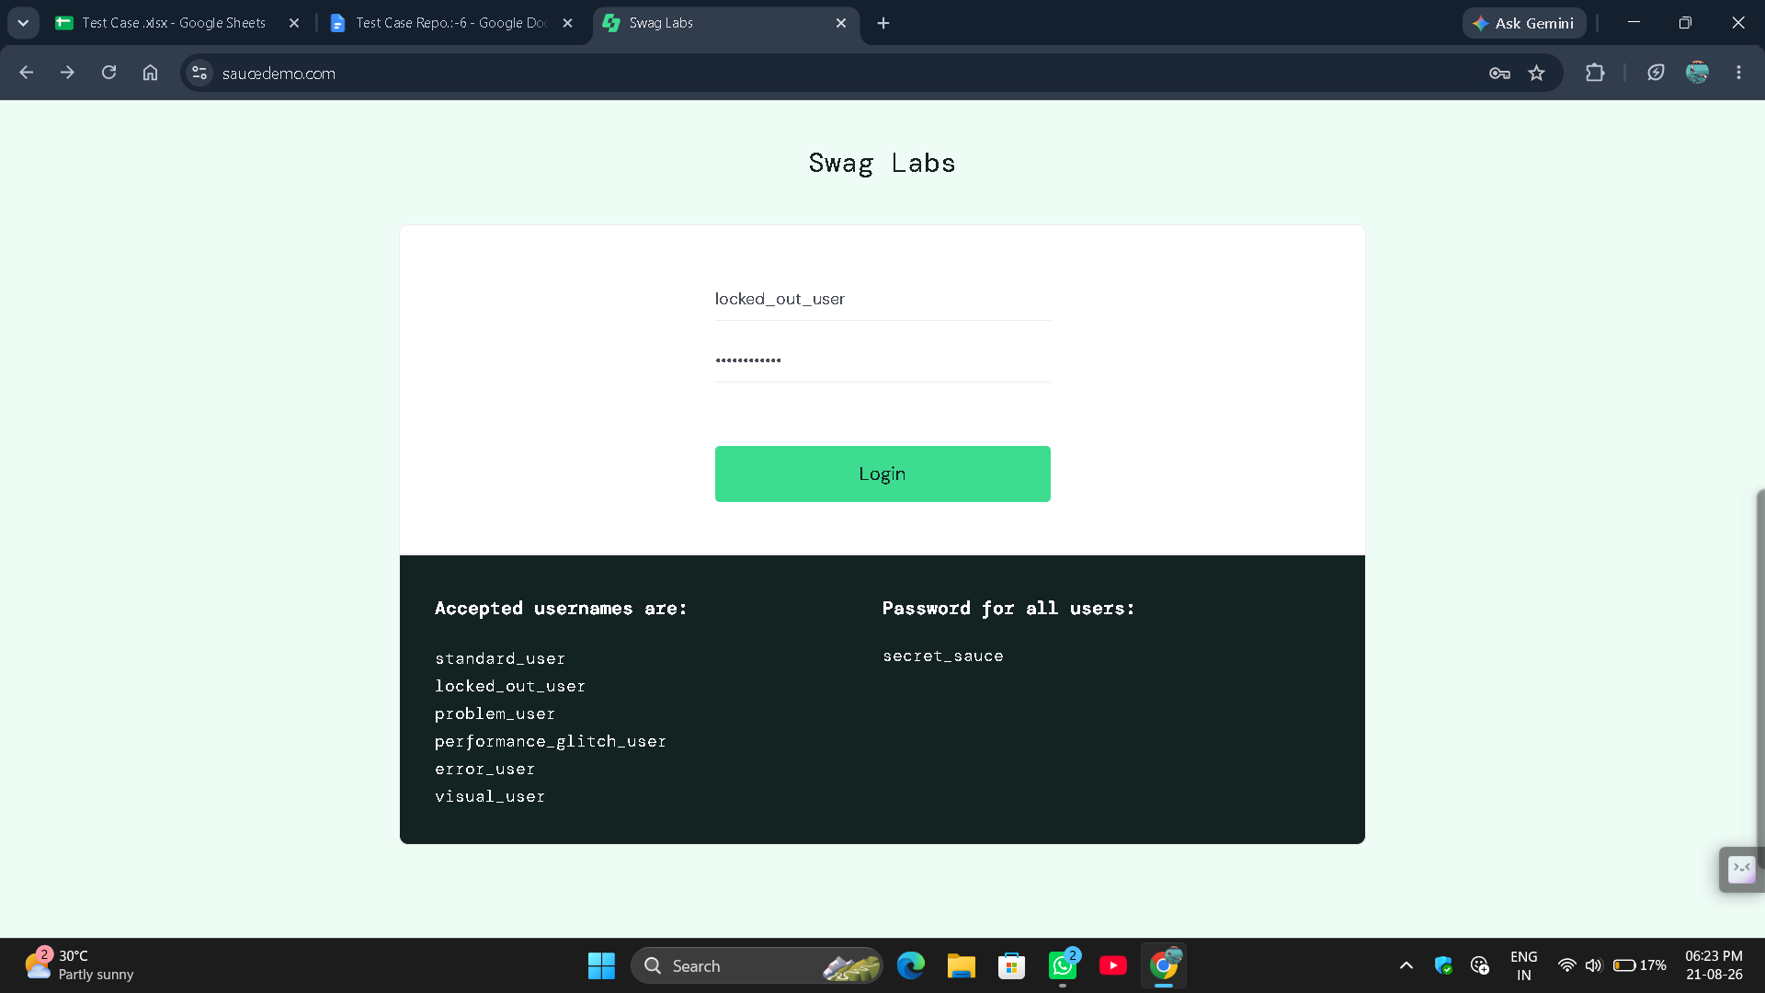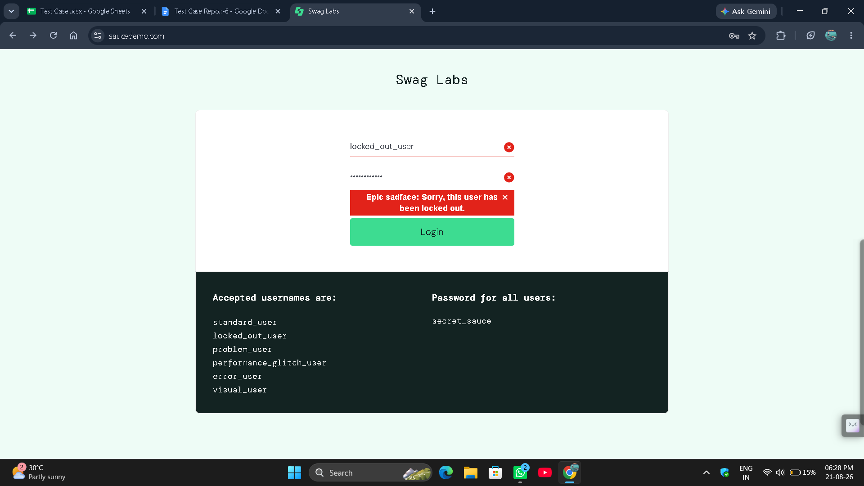

● Scenario ID: 6d
Scenario: Add product to cart
Test Steps:
- Open SauceDemo
- Login the Website
- Select the product
- Click on Add to cart
Screenshots:-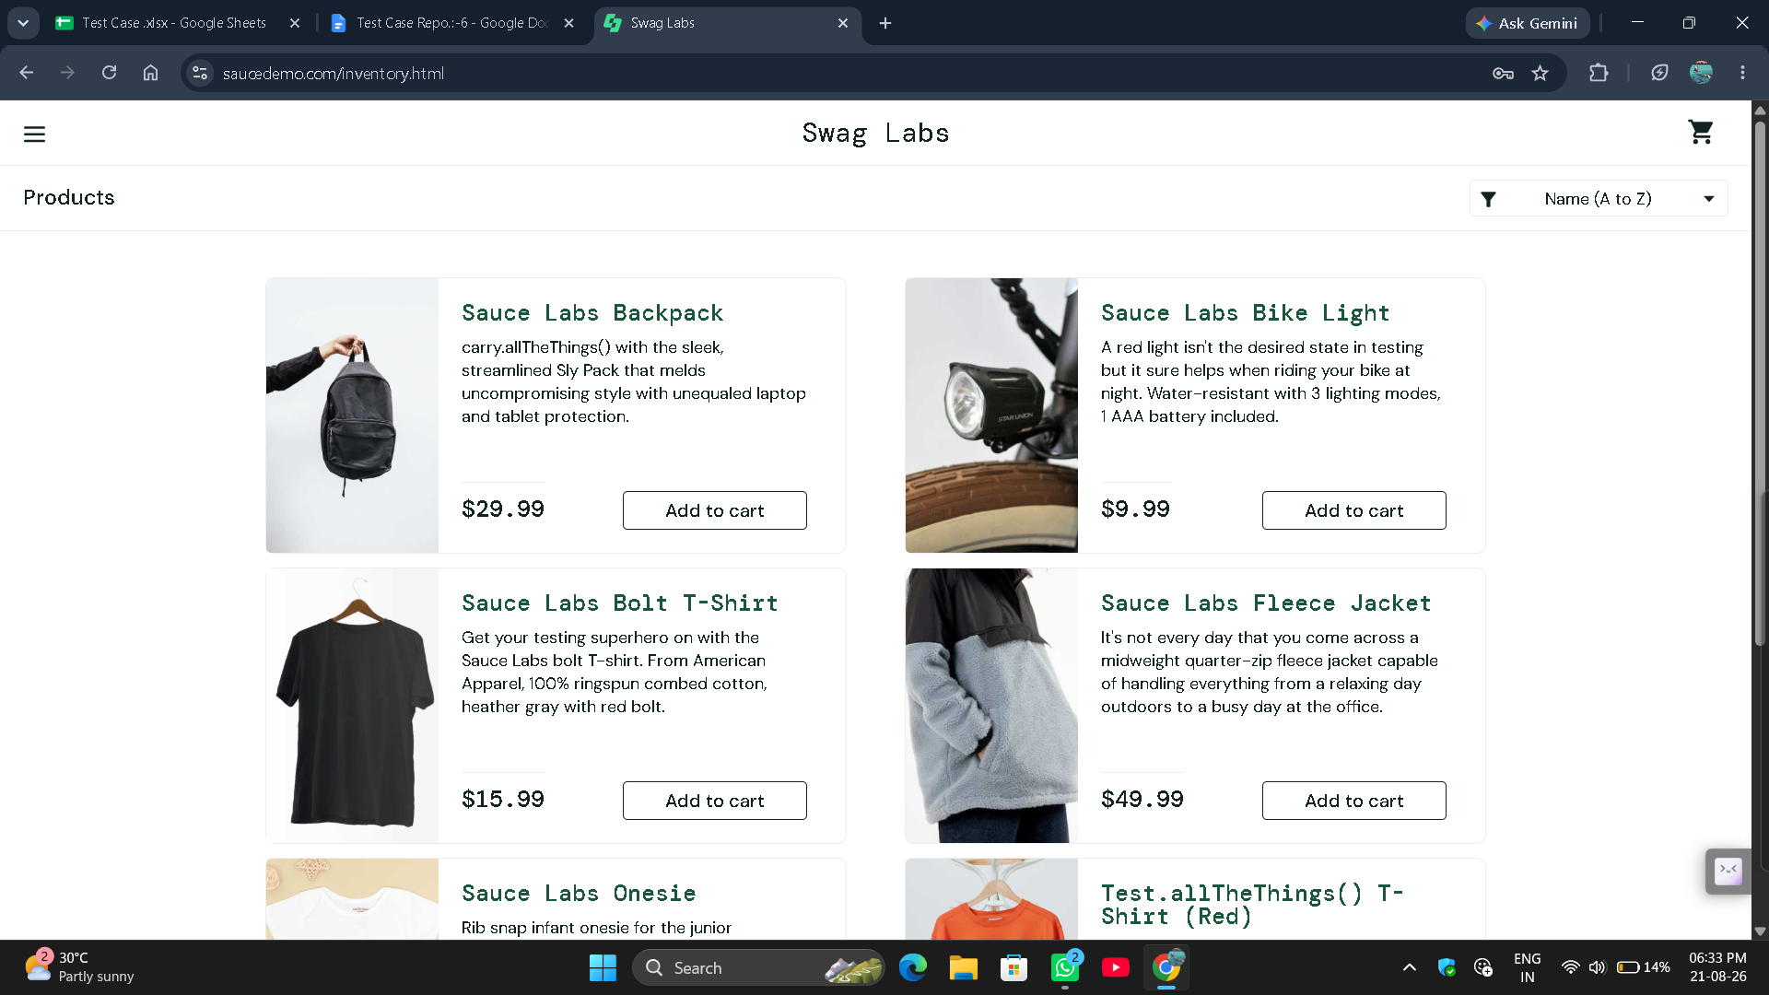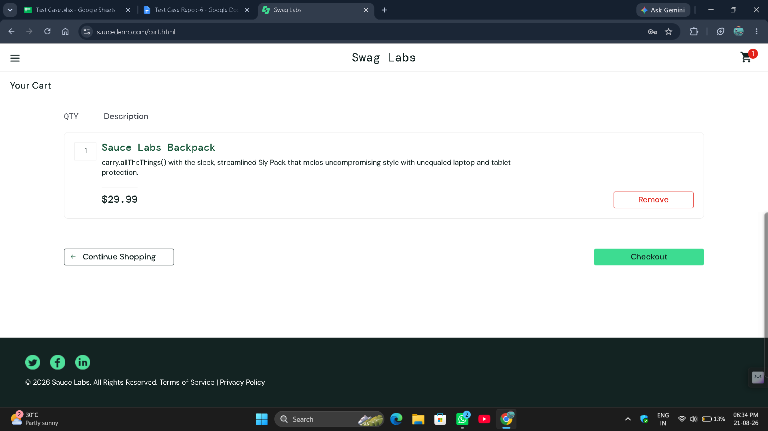

● Scenario ID: 6e
Scenario: Complete checkout with valid data
Test Steps:
- Open SauceDemo
- Click on add to cart
- Go to cart section
- Click on checkout
- Then fill your details and click on continue
Screenshots:-